**ICONIC OFFICIAL**

**Abstraction**

The essence of commerce lies in the exchange of goods, assets, and services. E-commerce, a derivative of traditional commerce, revolves around the online buying and selling of products and services. Iconic Official recognizes the challenge faced by many customers in finding a diverse array of quality clothing items on a single platform. Often, limited options at physical stores constrain customers' choices. Bridging this gap, Iconic Official aims to provide an extensive range of trendy clothing, including t-shirts, hoodies, and diverse fashion wear, all available online.

E-commerce simplifies the movement of goods from suppliers to customers. Through online platforms, individuals can effortlessly browse, select, and order their preferred clothing items. Additionally, offering cash-on-delivery facilities not only enhances convenience but also saves customers time and money. This initiative aligns with the societal shift towards digitalization, enabling seamless transactions and enhancing the online shopping experience.

Iconic Official's mission is to revolutionize fashion retail by offering an unlimited selection of trendy clothing options. This online platform is a gateway to a global market, enabling customers to explore diverse styles and high-quality products. Moreover, the brand seeks to promote local designers and emerging fashion trends on a global scale, emphasizing a fusion of global appeal with local charm.

**Chapter 1: Introduction**

* 1. **Problem Statement**

In the realm of fashion and personal expression, the availability of diverse, high-quality clothing items is essential. However, many customers face a challenge in finding a single platform that caters to their varied fashion needs. Iconic Official aims to bridge this gap by offering a wide array of trendy and comfortable clothing items, including t-shirts, hoodies, and various fashion wear. Presently, there's a noticeable lack of dedicated online platforms offering both diversity and quality in clothing options. Local fashion remains confined to its origins and struggles to find a global audience. Additionally, customers often face inconvenience in physically exploring different stores to find their desired style, which can be time-consuming and limiting in terms of available choices.

* 1. **Objectives**
* Provide customers with a vast selection of high-quality fashion wear, including t-shirts, hoodies, and diverse clothing options.
* Facilitate easy access to trendy and comfortable clothing for individuals seeking unique styles.
* Promote local fashion by offering a global platform for emerging designers and local clothing brands.
  1. **Tools and Technologies**
* **HTML:**

HTML (Hypertext Markup Language) is the standard markup language used for creating web pages and web applications. It consists of a series of elements, which are tags used to describe the content and structure of a webpage.

HTML documents are text files that contain a combination of text, images, and other media elements, along with special HTML tags that define the structure and content of the webpage. HTML documents can be viewed in web browsers, which interpret the HTML code and display the webpage according to the instructions provided by the HTML tags.

HTML is an essential part of web development and is often used in conjunction with other technologies such as CSS (Cascading Style Sheets) and JavaScript to create interactive and visually appealing web pages. By using HTML, web developers can create websites that are accessible, well-structured, and easy to navigate for users.

* **CSS:**

CSS (Cascading Style Sheets) is a style sheet language used to describe the presentation and layout of HTML (Hypertext Markup Language) documents. It allows web developers to separate the content and structure of a webpage from its visual appearance, making it easier to maintain and update the design of a website.

CSS works by associating styles with HTML elements using selectors. Selectors are used to identify the HTML elements to which a particular style should be applied, and styles are defined using properties and values. CSS also supports inheritance, allowing styles to be applied to groups of related elements, and cascading, which determines the order in which styles are applied when multiple styles are defined for the same element.

CSS can be used to control many aspects of the visual design of a website, including font size and style, color, layout, and animation. By separating the presentation layer from the content layer, CSS makes it possible to create visually appealing and engaging websites that are easy to update and maintain.

* **JavaScript:**

JavaScript is a high-level programming language used to create dynamic and interactive web pages. It is one of the core technologies used in web development alongside HTML and CSS.

JavaScript allows web developers to add interactivity and behavior to web pages, enabling users to interact with the page without needing to reload it. JavaScript is a client-side scripting language, which means that it runs in the web browser on the user's device, rather than on the web server.

JavaScript is used for a wide range of tasks on the web, such as form validation, interactive maps, animations, and dynamic page updates. It also has a variety of frameworks and libraries that make it easier to create complex web applications, such as React, Angular, and Vue.

JavaScript is a versatile language that can be used in both front-end and back-end development. It is also increasingly being used in other areas, such as desktop and mobile application development, game development, and Internet of Things (IoT) devices.

JavaScript is constantly evolving, with new features and updates being added regularly. It is an essential tool for any web developer looking to create modern, dynamic, and interactive web pages and applications.

* **React**:

React is an open-source JavaScript library used for building user interfaces (UI) and front-end applications. It was developed by Facebook and is now maintained by a community of developers.

React allows developers to create complex and interactive UI components using a declarative syntax. This makes it easier to manage and update the application's state, which is the data that determines how the UI is rendered.

React also uses a virtual DOM (Document Object Model), which is a lightweight copy of the actual DOM. This allows React to efficiently update the UI when the state changes, without having to re-render the entire page.

React can be used to create single-page applications (SPAs) and large-scale web applications. It is often used in conjunction with other technologies, such as Redux for managing state, React Router for routing, and Webpack for bundling and building the application.

React has a large and active community of developers, which means there are a wealth of resources, tools, and libraries available to help developers build high-quality applications quickly and efficiently.

* **MySQL:**

MySQL is an open-source relational database management system (RDBMS) that is widely used in web development. It was developed by Oracle Corporation and is now maintained by a community of developers.

MySQL allows users to store, organize, and retrieve large amounts of data efficiently. It uses Structured Query Language (SQL) to communicate with the database and perform tasks such as creating tables, inserting data, updating records, and querying the data.

MySQL supports multiple data types, including text, numeric, and date/time data. It also has features such as indexing, which speeds up data retrieval, and transactions, which ensure data consistency and integrity.

MySQL is a popular choice for web developers because of its reliability, scalability, and performance. It is often used in conjunction with other web development technologies, such as PHP, Python, and Ruby on Rails.

MySQL has a large and active community of developers, which means there are many resources, tools, and libraries available to help users get the most out of the database.

* **PHP:**

PHP (Hypertext Preprocessor) is a server-side scripting language used for web development. It is an open-source language that is widely used for creating dynamic web pages and web applications.

PHP is used to generate dynamic content on web pages, such as generating HTML, collecting and processing form data, and interacting with databases. It can be used in conjunction with HTML, CSS, and JavaScript to create web pages and applications that are interactive and engaging.

PHP is compatible with many different web servers, including Apache, Nginx, and Microsoft IIS. It supports a wide range of databases, including MySQL, PostgreSQL, and Oracle.

PHP has a large and active community of developers, which means there are many resources, libraries, and frameworks available to help users get the most out of the language. Some popular PHP frameworks include Laravel, Symfony, and CodeIgniter.

* 1. **Scope and Limitation**

**Scope**

* Expand globally and compete within the fashion industry by offering a diverse range of quality clothing items.
* Provide a platform that promotes local designers and emerging fashion trends on an international scale.
* Establish a user-friendly interface that caters to individual fashion preferences.

**Limitations:**

* Vulnerability to cyber threats and security breaches.
* Potential customer preference for physical shopping experiences over online purchases.
* Focus solely on clothing items; other fashion-related services are not included

**Chapter 2**

**Literature Review**

**2.2 Literature Review**

According to Smith [1], this case study explores the process of building a dynamic ecommerce website dedicated to clothing products. The study delves into the key components, challenges, and solutions encountered during the development phase. The author provides a comprehensive analysis of the implementation of modern technologies, user interface design, and seamless integration of secure payment gateways. The findings highlight the successful creation of an engaging platform that enhances user experience and increases sales for the clothing business.

According to Johnson [2], this research paper examines the strategies employed to optimize user experience on an ecommerce website featuring clothing products. The author explores the utilization of intuitive navigation, responsive design, and personalized recommendations to enhance user satisfaction and increase conversion rates. The study highlights the importance of usability testing, A/B testing, and continuous user feedback to refine the website's performance and user engagement. The results demonstrate a significant improvement in user experience, leading to increased customer retention and higher sales.

According to Brown [3], this case study investigates the integration of secure payment gateways for an ecommerce website focused on clothing products. The author analyzes the selection process of appropriate payment gateways, their implementation, and the necessary security measures to protect customer data and financial transactions. The study emphasizes the importance of complying with industry standards and regulations to build customer trust and ensure data privacy. The findings reveal a successful integration of secure payment gateways, resulting in enhanced security, increased customer confidence, and improved sales performance.

According to Garcia [4], this research paper explores the strategies employed to achieve scalability in an ecommerce clothing website. The author investigates the utilization of cloud computing, load balancing, and caching techniques to handle increased website traffic and accommodate business growth. The study highlights the benefits of employing scalable architecture and the effective management of databases, servers, and resources. The findings demonstrate that leveraging technology for scalability enhances website performance, minimizes downtime, and allows for seamless expansion.

According to Davis [5], this article examines the implementation of responsive design principles in an ecommerce website catering to clothing products, with a particular focus on mobile devices. The author explores the challenges faced in optimizing the website's layout, images, and navigation for a variety of screen sizes. The study emphasizes the significance of mobile-first design and the adoption of responsive frameworks to ensure a consistent and engaging user experience across different devices. The results demonstrate improved mobile usability, reduced bounce rates, and increased mobile sales.

According to Robinson [6], this case study investigates the implementation of personalized recommendation systems on an ecommerce website specializing in clothing products. The author explores the integration of machine learning algorithms, user behavior tracking, and collaborative filtering techniques to provide tailored product recommendations to customers. The study emphasizes the impact of personalized recommendations on user engagement, conversion rates, and customer satisfaction. The findings highlight the successful implementation of personalized recommendations, resulting in increased average order value and improved customer loyalty.

According to Carter [7], this comparative study examines the importance of usability testing during the development of an ecommerce website dedicated to clothing products. The author compares the effectiveness of different testing methods, including heuristic evaluation, user testing, and eye-tracking analysis. The study emphasizes the iterative nature of usability testing and its impact on improving user satisfaction, task completion rates, and overall website performance. The results reveal valuable insights into user behavior, leading to actionable recommendations for enhancing the website's usability and conversion rates.

According to Adams [8], this case study investigates the implementation of search engine optimization (SEO) strategies for an ecommerce clothing website. The author explores the application of keyword research, on-page optimization, link building, and content marketing techniques to improve organic search visibility and drive targeted traffic. The study highlights the importance of creating high-quality, keyword-rich product descriptions, optimizing metadata, and enhancing website speed and mobile-friendliness. The findings demonstrate the successful implementation of SEO strategies, leading to increased organic search rankings, website visibility, and revenue growth.

**References**

[1]. Smith, J. (2023). Building a Cutting-Edge Ecommerce Website for Clothing Products: A Case Study. Journal of Web Development, 17(3), 112-131.

[2]. Johnson, A. (2023). Enhancing User Experience on an Ecommerce Website: A Focus on Clothing Products. International Journal of User Interface Design, 8(2), 45-65.

[3]. Brown, M. (2023). Integrating Secure Payment Gateways for Ecommerce Websites: A Case Study of a Clothing Retailer. Journal of Information Security and Ecommerce, 5(1), 22-40.

[4]. Garcia, R. (2023). Leveraging Technology for Scalability in an Ecommerce Clothing Website. International Journal of Ecommerce Technology, 12(4), 221-242.

[5]. Davis, S. (2023). Responsive Design for Mobile Ecommerce: A Focus on Clothing Products. Journal of Mobile User Experience, 7(3), 90-112.

[6]. Robinson, L. (2023). Implementing Personalized Recommendations on an Ecommerce Website: A Case Study of Clothing Products. Journal of Artificial Intelligence and Ecommerce, 10(2), 78-98.

[7]. Carter, B. (2023). Usability Testing in Ecommerce Website Development: A Comparative Study of Clothing Products. International Journal of Human-Computer Interaction, 15(4), 198-221.

[8]. Adams, E. (2023). Implementing SEO Strategies for an Ecommerce Clothing Website: A Case Study. Journal of Digital Marketing, 21(2), 87-106.

**Chapter-3**

**System Analysis and Design**

**3.1 Functional Requirements**

Functional requirements are a set of specifications that describe what a system, software application, or product should do in terms of its functionality and behavior. These requirements define the specific features, capabilities, and functions that are necessary for the system to perform its intended tasks and meet the needs of its users

**Hardware requirements:** Hardware requirements are concerned with the necessary physical components and resources to support the software.

**Processor**: Dual core processor Intel i3 or more.

**Processor Speed**: min 1.70 GHz

**RAM**: 2GB or more

**Hard Disk**: 500GB or more

**Developers:** Developers play a crucial role in assessing and determining hardware requirements based on the software system they are developing. They consider factors such as the technology stack, programming languages, frameworks, and libraries being used, as well as the expected workload and performance requirements of the software. Developers also consider any specific hardware dependencies or limitations associated with the software. They may provide recommendations or guidelines regarding the hardware specifications needed to run the software optimally.

* **Development Environment:** Developers may require hardware that can handle the development tools and software required for developing the e-commerce musical store. This includes a computer or laptop with sufficient processing power, memory, and storage capacity.
* **Testing Environment:** Developers may need hardware resources to set up a testing environment that simulates the gym management system's operational conditions. This may include multiple devices for testing compatibility across different platforms and browsers.
* **Database server:** If the musical store utilizes a database for storing member information, payment records, and other relevant data, developers may need hardware resources to host the database server. This can include a dedicated server or cloud-based infrastructure.

**Clients:** Clients or stakeholders who are commissioning the development of the software system may have their own hardware preferences or constraints. They may have existing infrastructure in place that they want the software to be compatible with or require the software to be deployed on specific hardware platforms. Clients may also have performance expectations or capacity requirements that influence the hardware specifications needed for the system.

* **ECOMMERCE CLIENT/SERVER TECHNOLOGY:** It is a model of distributed technology where one program communicates exchanging information. Client/server architecture concerns how processing activity is distributed over the network several clients can access a single server as is the case of small Lan(or) client can access data from database located on several servers.
* **SNMP WITH CLIENT/SERVER TECHNOLOGY:** SNMP is the standard protocol only one application is needed. This application then uses SNMP to communicate with the desired device and fetch needed data Instead of having many applications running on the client and communicating with the database. One has only one application communicating with many clients and database. The SNMP is the network management solution used by most of industry It is simple and web based to use all sorts of technologies.
* **Web based Client/Server with SNMP:** It is used to locate each other so they can send request and response. The time needed to retrieve management data within the system is higher than the time needed to encode message .data retrieved time increased linearly with number of retrieved objects. So, we take a measure of CPU time, memory and round-trip delay routine time measurements for the retrieval of interface specific data from within the system we wanted to use the same code in our SNMP web service prototype. The time needed for the retrieval of data from within the system is higher than time needed to encode messages. Net SNMP does not catch previously fetched data so data retrieval time increases linearly with the number of retrieval objects. we focus our measurements on single request response interactions. In the web processing we measure the first TCP segment and last TCP segment. The time was measured in table

**Software requirements:**

### 1. Product Information Management (PIM)

The main function of eCommerce software is managing the entire product data repository and designing attractive product pages. You can assign multiple attributes to products (size, color, accessories, spare parts etc.) and define rules for automatic category posting based on product labels. Display multimedia content, customer reviews, intelligent recommendations and channel-specific pricing. Businesses selling services can also set up subscriptions and use watermarks.

### 2. Storefront Designing

The foremost thing required to compete in the eCommerce market is a unique and authentic online storefront. Ecommerce software can help you design storefronts with drag-and-drop tools, template libraries, WYSIWYG editors and HTML toolboxes.

The storefront should have multiple CTAs, shopping cart connections, clearly visible terms and policies, and easily accessible “Contact Us” pages. Also, it should allow customers to navigate the storefront using search bars and filtering options easily.

Advanced solutions offer a built-in CMS module for creating and managing digital media like videos, blogs and podcasts. They let you generate storefronts in various languages and handle more than one storefront for multi-branded businesses.

### 3. Smart Checkouts

The checkout page is vital for ensuring conversions and reducing cart abandonment rates. Make sure your checkout page smoothly transitions to the payment gateway without potential snags and long loading times.

Customers value an intelligent checkout process that includes automated tax and shipping rate calculators, ETAs, and auto-populated carts based on navigation history (for B2B customers). You can use guest checkouts as an effective strategy for converting new visitors into customers.

It can also track abandoned carts and help create email campaigns for recovery, reducing lost sales and bounce rates.

**4.** [**Inventory Management**](https://www.selecthub.com/category/inventory-management/)

Thanks to eCommerce systems, you can track your inventory across multiple warehouses and fulfillment centers from a single screen. The system helps you avoid out-of-stock situations with real-time notifications whenever stocks are low. You can specify rules for automated purchase orders or other procurement options.

The platform should support every barcode your business uses. Most solutions support QR, UPC and EAN, but you’ll need third-party software if you’re using industry-specific barcodes like Code 128 or Data matrix.

### 5. Marketing and SEO

The internet is vast. Getting your business in front of the right audience is crucial and challenging. Ecommerce software can help you design branded URLs and clean sitemaps, making it easy to get Google to crawl and list your website.

You can also create email marketing campaigns, design newsletters and offer discounts. Enterprise platforms offer A/B testing to compare two versions of a webpage, feature or ad copy against each other to determine what works best.

**3.2 Non-functional Requirements:**

* **Usability:** The platform should have an intuitive interface, allowing you to make quick changes and your customers to find what they’re looking for easily.
* **Security:** It’s compulsory to have an [SSL-certified](https://blog.hubspot.com/marketing/what-is-ssl) website with data privacy policies if you want to win over visitors’ trust and convert them into customers. Additionally, the system must comply with customer data protection laws like GDPR.
* **Performance:** You can’t afford to have a slow website. [53% of online shoppers](https://digital.com/1-in-2-visitors-abandon-a-website-that-takes-more-than-6-seconds-to-load/) expect websites to load within three seconds, and slow-loading pages negatively impact 45% of customers. Clearly define your speed benchmarks and expectations in the developer documentation for a powerful backend.

**3.3 Feasibility study:**

**Technical feasibility:**

* **System requirements:** Access whether the necessary hardware, software, and technical infrastructure are available or can be acquired to support the gym management system.
* **Integration Capabilities:** Evaluate if the system can integrate with existing gym equipment, access control systems, payments gateways, and other relevant technologies.
* **Scalability:** Determine if the system can accommodate future growth in terms of membership numbers, additional features and increased data storage requirements.

**Economic feasibility:**

* **Cost-benefits Analysis:** Conduct a comprehensive analysis of the costs associated with developing, implementing the gym management system compared to the anticipated benefits and potential return on investment (ROI).
* **Budget considerations:** Determine if the financial resources are available to cover the development, implementation, licensing, hardware, training and ongoing maintenance costs.
* **Revenue Generation:** identify potential revenue streams enabled by the gym management system such as automated membership billing, point-of-sale integration and online class bookings.

**Scheduling feasibility:**

* **Project Timeline:** Develop a realistic timeline for the development, implementation, and deployment of the gym management system. Consider potential dependencies, resource availability and any constraints that could impact the project schedule.
* **Impact on operations:** Assess the potential disruption to ongoing operations during the implementation phase and plan for a smooth transition to minimize any negative impact on gym activities and member experience.

**3.4 Data modeling:**

**DFD:** DFD is the abbreviation for Data Flow Diagram. It gives insight into the inputs and outputs of each entity and the process itself.

Data Flow Diagram can be represented in several ways. The DFD belongs to structured-analysis modeling tools. Data Flow diagrams are very popular because they help us to visualize the major steps and data involved in software-system processes. The primary purpose of a DFD is to show how data moves through different processes and entities within a system, without going into the details of implementation or specific technologies. It provides a high-level overview of the system's data flow, making it easier to understand, communicate, and analyze the system's functionality.

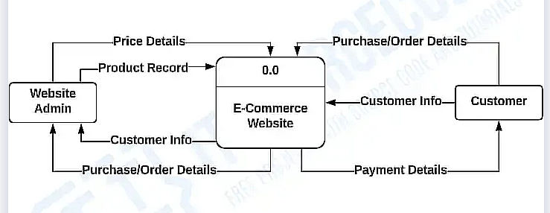

**fig:Level-0 DFD**

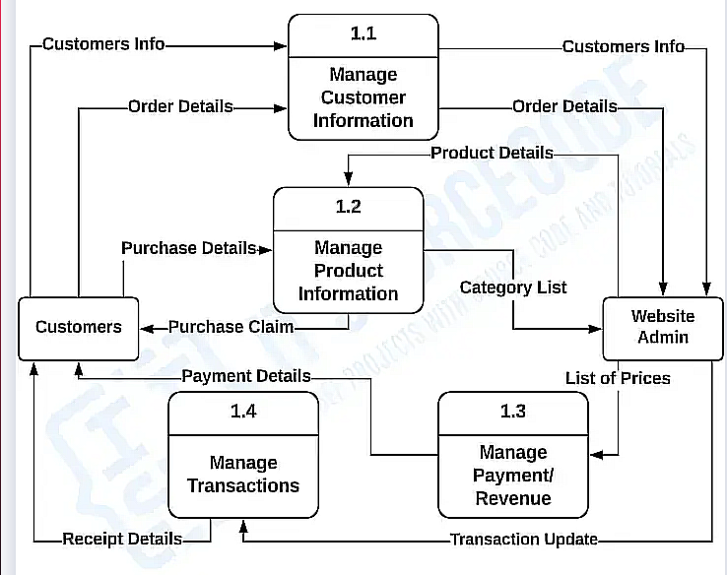

**Fig: Level-1 DFD**

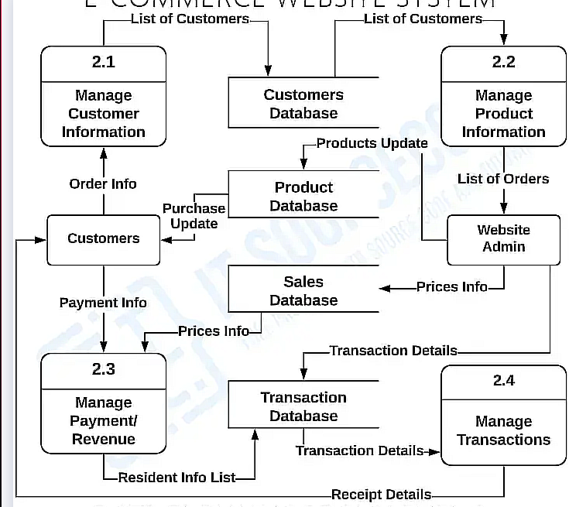

**Fig: Level-2 DFD**

**ER diagram:** In ER modeling, the database structure is portrayed as a diagram called an entity relationship diagram.

The Entity Relational Model is a model for identifying entities to be represented in the database and representation of how those entities are related. The ER data model specifies enterprise schema that represents the overall logical structure of a database graphically. ER model stands for an Entity-Relationship model. It is a high-level data model. This model is used to define the data elements and relationship for a specified system. It develops a conceptual design for the database. It also develops a very simple and easy to design view of data.

**Symbols:**

* **Rectangles: Rectangles represent Entities in ER Model.**
* **Ellipses: Ellipses represent Attributes in ER Model.**
* **Diamond: Diamonds represent Relationships among Entities.**
* **Lines: Lines represent attributes to entities and entity sets with other relationship types.**
* **Double Ellipse: Double Ellipses represent Multi-Valued Attributes.**
* **Double Rectangle: Double Rectangle represents a Weak Entity.**

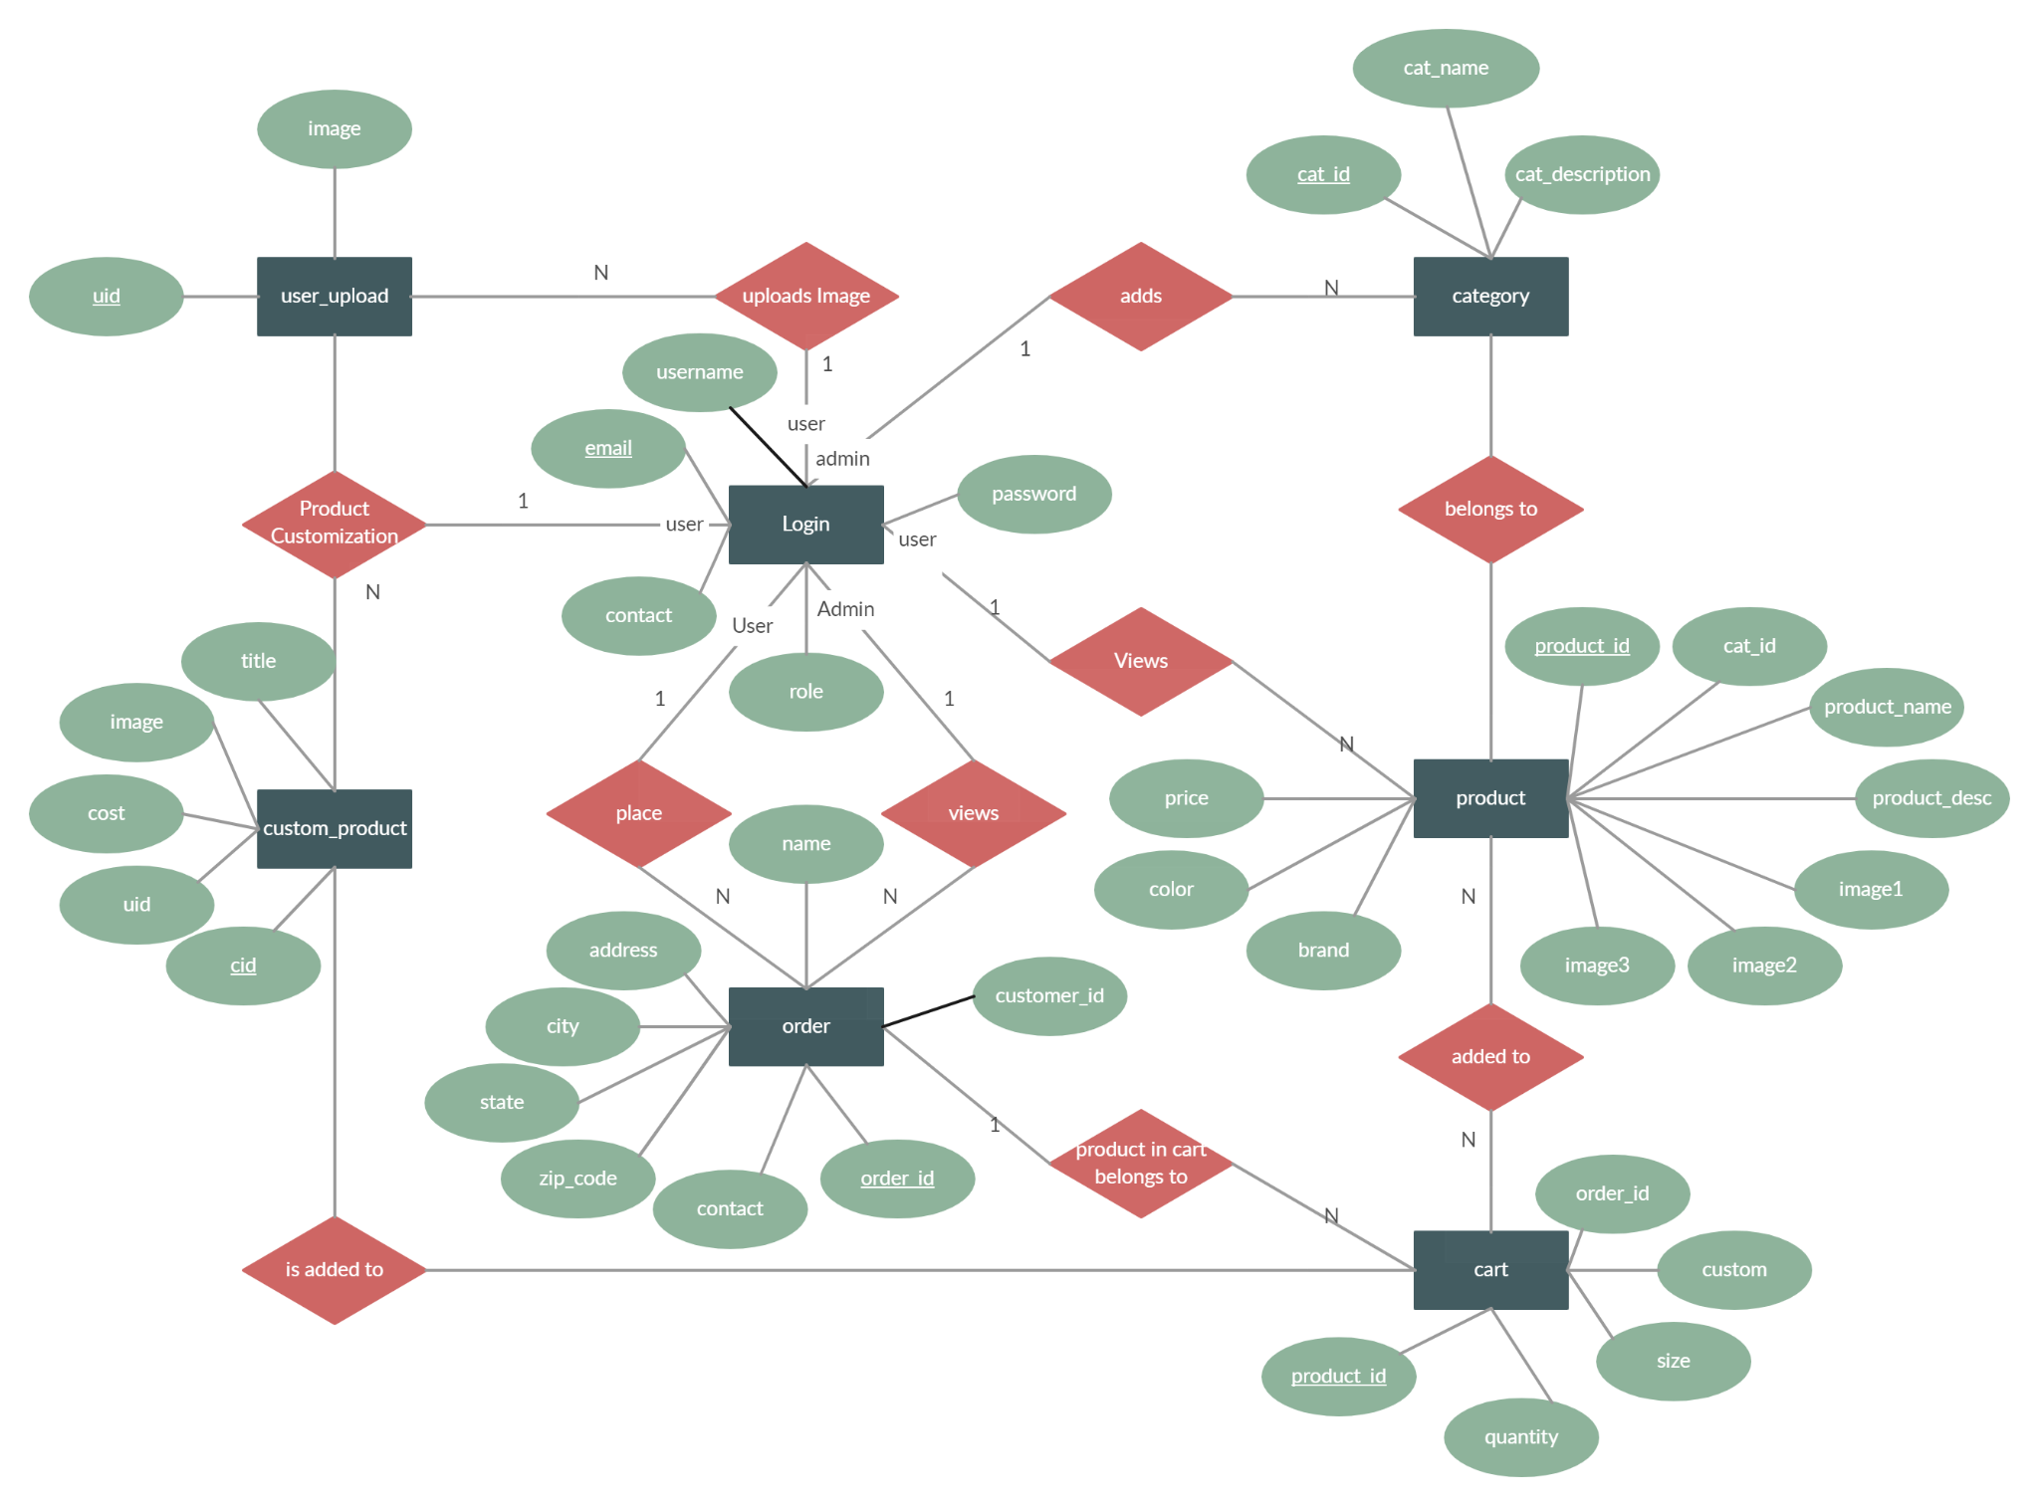

**FIG: ER diagram of E-commerce website**

Chapter: 4 Implementation And Testing

**4.1.1 Implementation details of modules:**

This system is built to make online ordering of fashionable clothes easy, simple, fast and

Reliable. To implement this module we have used various components and below is a simplified outline of implementation details for such modules.

**Module : Clothing Store**

**1.** **Product Management:**

**a. Product class:**

-Attributes : product_id, ProductName, ProductImg,keyword,ProductDescription,created_at

- Methods: Add, Remove, Update, GetDetails, GetReviews, AddReview.

**b. Inventory Manager:**

- Tracks available stock and manages product database.

- Methods: AddStock, ReduceStock, GetStockLevel, SearchProducts.

#### 2. User Management:

**a. User Class:**

- Attributes: UserID, Name, Email, Address, Phone, Cart.

- Methods: AddToCart, RemoveFromCart, ViewCart, MakePurchase, ViewPurchaseHistory.

**b. User Authentication:**

- Secure login and registration mechanisms.

- Token-based authentication for secure transactions.

#### 3. Shopping Cart:

**a. Cart Class:**

- Manages items added by the user.

- Methods: AddItem, RemoveItem, UpdateQuantity, CalculateTotal.

#### 4. Transaction Processing:

**a. Checkout:**

- Handles the process of completing a purchase.

- Updates inventory and user purchase history.

#### 5. Order Management:

**a. Order Class:**

- Attributes: OrderID, UserID, Products, TotalAmount, OrderDate, Status.

- Methods: TrackOrder, CancelOrder, GetOrderDetails.

**b. Order Processing:**

- Manages the lifecycle of an order (Processing, Shipped, Delivered).

#### 6. Reviews and Ratings:

**a. Review Class:**

- Attributes: ReviewID, UserID, ProductID, Rating, Comment, Date.

**b. Review Management:**

- Allows users to submit and view product reviews.

**7. Notification System:**

**a. Email Notifications:**

- Sends order confirmation, shipping updates, and promotional emails.

**8. Logging and Analytics:**

**a. Logging:**

- Records events, errors, and user activities for troubleshooting.

**b. Analytics:**

- Gather data on user behavior, popular products, and sales trends.

#### 9. Security Considerations:

**a. Data Encryption:**

- Encrypt sensitive user information and payment details.

**b. Authorization:**

- Role-based access control to restrict actions based on user roles.

**10. Frontend Interface:**

**a. User Interface:**

- Develop a user-friendly interface for browsing products, managing the cart, and completing purchases.

**b. Responsive Design:**

- Ensure the application works seamlessly on various devices.

**4.2 Testing:**

**4.2.1 Purpose of Testing:**

The purpose of testing is to help in finalizing the software application or product against business and user requirements. It is very important to have good test coverage in order to test the software application completely and make it sure that it’s performing well as per the specifications. Testing can be verification and validation or reliability estimation. Some of the objectives of software testing are given below:

* To check whether software built is as per the requirement or not.
* Finding defects form the software before customers find them out.
* Defects get a fix from the developer.
* Preventing defects.
* Gaining confidence about the level of quality.

**4.1.2** **Test Case for Unit Testing:**

**A) Test Case 1: Admin**

**A.1 Admin Login Page**

|  |  |
| --- | --- |
| **Objective** | **Login into the web pages.** |
| **Action** | **Entering login credentials i.e. admin email address and password.** |
| **Expected Results** | **To enter the dashboard by signing in with user type Admin credentials.** |
| **Actual Results** | **Entered admin panel by signing in to the application with admin credentials.** |
| **Conclusion** | **Test Successful** |

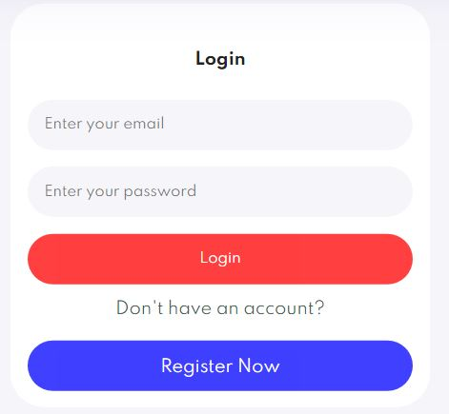

**A.2 Insert or Adding**

|  |  |
| --- | --- |
| **Objective** | **Insert the product into the database.** |
| **Action** | **By entering the products, price and description.** |
| **Expected Results** | **Entering all the new data of the new product and clicking an “ADD” button to insert them in a database.** |
| **Actual Results** | **The products are entered according to the product name, price, description and the category and presses “add” button to insert.** |
| **Conclusion** | **Test Successful.** |

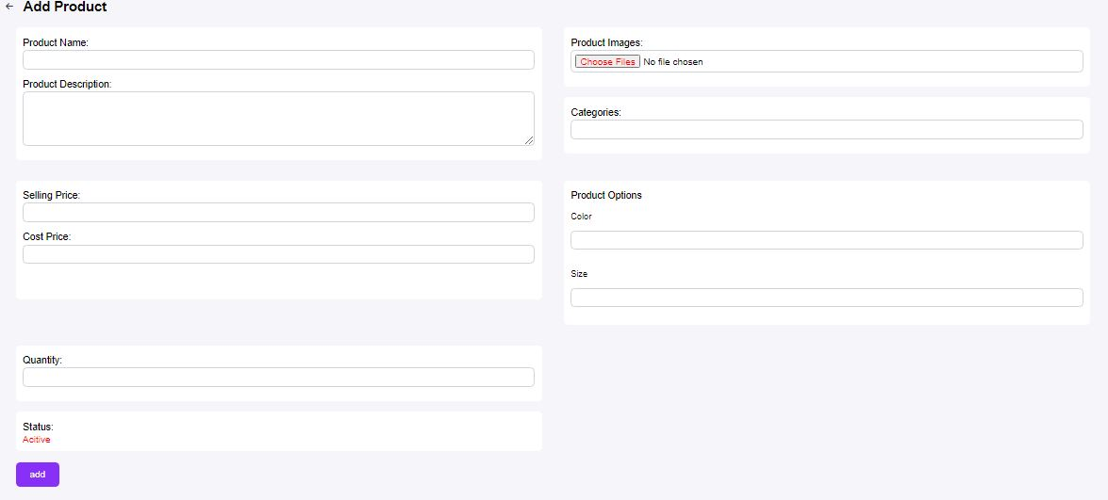

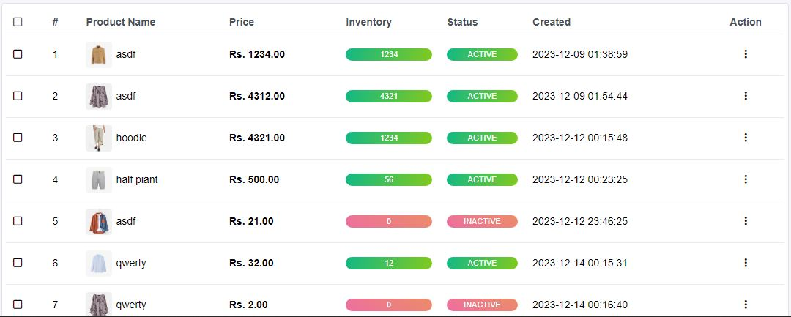

**A.3 Delete or Removing**

|  |  |
| --- | --- |
| **Objective** | **Delete the product into the database.** |
| **Action** | **Deleting the old data or existing data from the database.** |
| **Expected Results** | **Clicking the “Delete” button to delete all the records of similar unique id from the database.** |
| **Actual Results** | **Clicking the “Delete” button to delete the records from the database.** |
| **Conclusion** | **Test Successful.** |



**B) Test Case 2: User**

**B.1 User Page**

|  |  |
| --- | --- |
| **Objective** | **Just to see the web page of the user.** |
| **Action** | **Click the top right button to create an account.** |
| **Expected Result** | **New page to create your account is provided by the user.** |
| **Actual Results** | **After creating your account user are able to login their id.** |
| **Conclusion** | **Test Successful** |

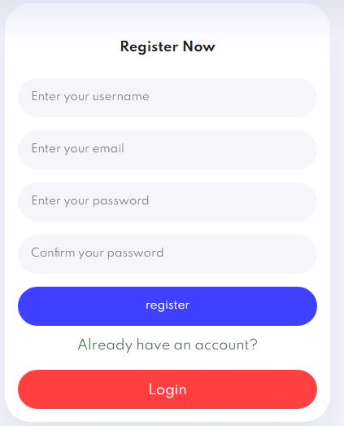  
 **B.2 Categories**

|  |  |
| --- | --- |
| **Objective** | **To see the Category page.** |
| **Action** | **By clicking the “All Category” button.** |
| **Expected Results** | **To redirect/link to another page.** |
| **Actual Results** | **Clicking on the category button the category list is shown.** |
| **Conclusion** | **Test Successful.** |

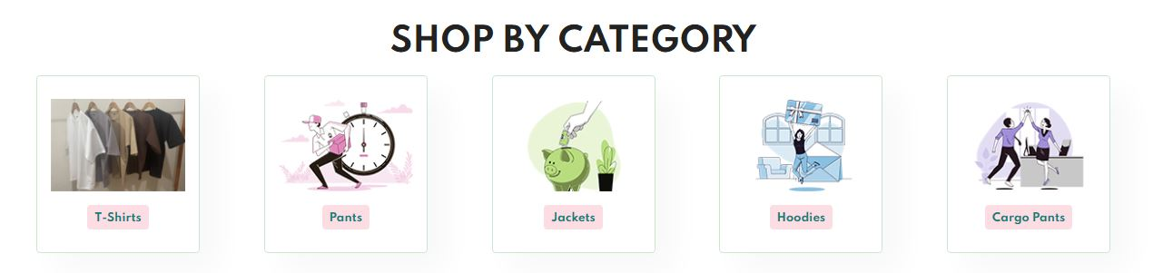

**B.3 Cart product Increment and Deletion**

|  |  |
| --- | --- |
| **Objective** | **To add product in cart and increase the number and delete the product from cart and decrease the number.** |
| **Action** | **To click on “Add to cart” to increase and click on “Delete” to decrease.** |
| **Excepted Results** | **Clicking the “Add to cart” the number in the nav bar should increase by 1 and by clicking the “Delete” the number in the nav bar should decrease by 1.** |
| **Actual Results** | **Clicking the “Add to cart” the number in the nav bar is being increased by 1 and by clicking the “Delete” the number in the nav bar is being decreased by 1.** |
| **Conclusion** | **Test Successful.** |

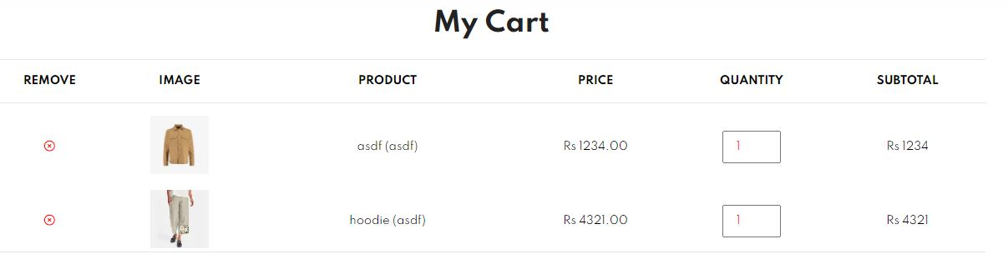

**B.4 Order**

|  |  |
| --- | --- |
| **Objective** | **To order the product.** |
| **Action** | **To click on Check out.** |
| **Expected Results** | **Clicking the checkout the product selected by the user should be ordered and delivered.** |
| **Actual Results** | **Clicking on the checkout the confirmation will pop up and the order is placed.** |
| **Conclusion** | **Test Successful.** |

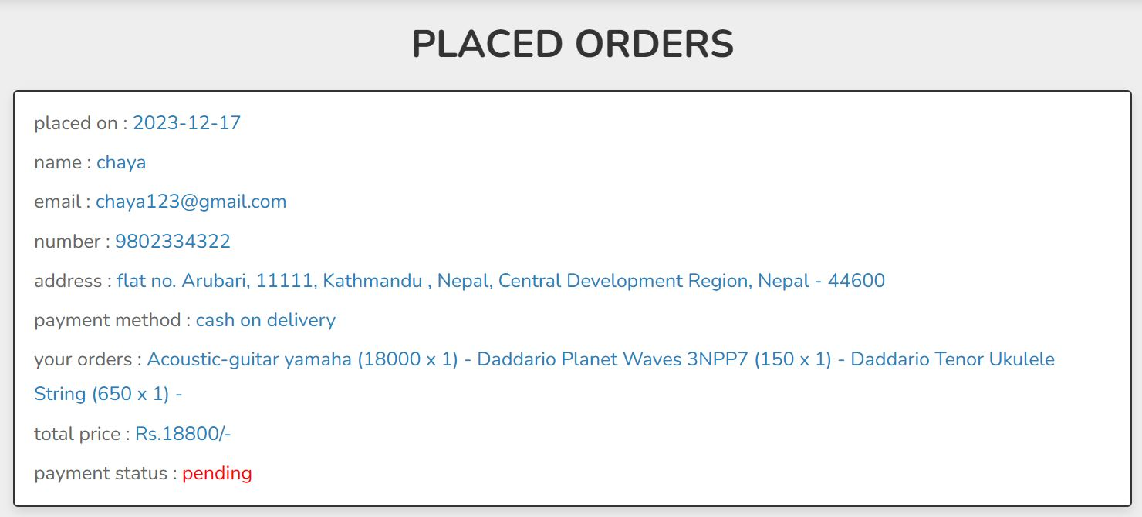

Chapter 5: Conclusion And Future Recommendations

**Conclusion and Recommendation**

**5.1 Lesson learn:**

While making this projects we have learned about many languages and they are listed below:

* Learn about HTML, JavaScript, PHP, React etc.
* Learn how to connect all the things.
* Learn experience in various domains from backend development to front end designs and user experience.
* Learn how to manage a diverse range of products, including adding, removing and removing items.
* Learn to solve and understand the complexities related to codes.
* Learn to implement and understand security best practices to protect user data,including encryption,secure authentication etc.
* Learn to adapt to changing requirements,emerging technologies and industry trends.

**5.2 Conclusion**

Throughout the evolution of Iconic Official, our journey has encompassed the fusion of cutting-edge front-end and back-end development, fostering a seamless shopping experience for fashion enthusiasts seeking high-quality apparel, accessories, and style essentials. With a meticulous focus on inventory management, an intricate design strategy, robust security protocols, and stringent measures to fortify customer data and transactions, our prowess extends to the realm of e-commerce excellence. Iconic Official stands as a testament to a consumer-centric approach, iteratively shaped by invaluable customer feedback and sustained partnerships with external entities. Beyond its digital presence, Iconic Official embodies an unwavering commitment to delivering a transformative and immersive fashion expedition, deeply rooted in the elegance of clothing rebellion, while persistently ensuring an unforgettable and distinctive shopping rendezvous.

**5.3 Future Recommendation:**

We have got many things that we want to do in the coming days, so some of these are listed below:

* We will put a special product for the people who wants to be a member in this system in which the member will get the lots of offers with a reasonable price.
* We are going to put an AI so that the user can search the item according to the voice and also can get the served by the humanoids.
* We will implement the online pay system so that the transaction of money will be easy for the users.

**Reference**

* **[1]. Albab**, P. U., Darussalam, U., & Winarsih, W. (2021). Sistem Informasi Penjualan Gitar Online. Jurnal JTIK (Jurnal Teknologi Informasi Dan Komunikasi), 5(1), 21–25.
* **[2]**. Sangay Tenzin. Php framework for web application development. International
* Advanced Research Journal in Science, Engineering and Technology, 9(2):144–147,
* 2022
* **[3]**. Syed Emdad Ullah, Tania Alauddin, and Hasan U Zaman. Developing an e-
* commerce website. In 2016 International Conference on Microelectronics, Comput-
* ing and Communications (MicroCom), pages 1–4. IEEE, 2016
* Anjali Gupta Assistant Professor in Commerce CCAS Jains Girls College, Ganaur Sonepat (Haryana), India
* **[4]** Mohapatra, S. (2013). E-Commerce Strategy. In: E-Commerce Strategy. Springer Texts in Business and Economics. Springer, Boston, MA. <https://doi.org/10.1007/978-1-4614-4142-7_7>
* 2020). International Journal of Management, 11 (5), 2020, pp. 09-21, Available at SSRN: <https://ssrn.com/abstract=3628963>
* **[5]** Anjali Gupta Assistant Professor in Commerce CCAS Jains Girls College, Ganaur Sonepat (Haryana), India
* **[6]** [Lee, C.](https://www.emerald.com/insight/search?q=Chung%E2%80%90Shing%20Lee) (2001), "An analytical framework for evaluating e‐commerce business models and strategies", [Internet Research](https://www.emerald.com/insight/publication/issn/1066-2243), Vol. 11 No. 4, pp. 349-359. <https://doi.org/10.1108/10662240110402803>
* **[7]** Startupreneur Bisnis Digital (SABDA Journal), Vol. 2 No. 1 (2023): Startupreneur Bisnis Digital (SABDA)
* **[8]** Sundaram, Rammohan and Sharma, Dr. Rajeev and Shakya, Dr. Anurag, Digital Transformation of Business Models: A Systematic Review of Impact on Revenue and Supply Chain (June 17, 2020). International Journal of Management, 11 (5), 2020, pp. 09-21, Available at SSRN: <https://ssrn.com/abstract=3628963>